Welcome!
Date
Name
Spouse
Address
City
State Zip _________
Email

Please Contact By
❑ Card  Phone  Visit

Telephone Best Time to Call
Home ______________
Work ______________

Guest: First Time Second Time
Are you a church member: yes no
Church
City, State

Circle Appropriate Age/Grade Group(s)
Preschool: Ages: B-1 2-3 4-5
Children: Grades: K 1 2 3 4 5 6
Youth: Grades: 7 8 9 10 11 12
Adults: Ages:18-29 30s 40s 50s 60s+

How did you learn about our church?
Newspaper Friend Yellow Pages Mail
Other

I am a guest of:

New in the Community? Yes No
Names & ages of children at home

Weekly Service & Activity Schedule

October 11, 2015

9:45 a.m. Sunday School
11:00 a.m. Worship Service
6:00 p.m. Evening Worship/ Business Meeting

Week of October 11, 2015
Wednesday 6:30 pm Meal/ Adult Bible Study

Upcoming Events

October
18……...Independence Baptist Assoc. Mtg – Chappel Hill
(no Sunday evening service)
22…………………………….……………….Adult Fellowship
25………………………..…………High Attendance Sunday
November
8-10……………………………………BGCT Annual Meeting
12……………………………………………..Adult Fellowship
14………………………………………………….Harvest Stew
Sunday, October 18 is the cutoff date for all cookbook recipes to be submitted, either to the Cookbook Committee or the recipe database. The ladies are trying to have these books ready for Christmas. Thanks to all who have contributed!!


October 25, join us and bring a friend or 2….or more!

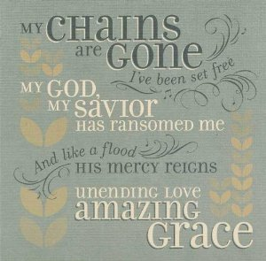

Knobbs Springs Baptist Church

October 11, 2015

Church Information:

KnobbsSpringsBC.com KnobbsSpringsBaptist@gmail.com

1662 CR 305, McDade, Texas 78650 512-273-2743

David Atwood, Pastor Cell 512-470-5098
Home 512-856-2819
Patti Radford, Office Manager Cell 512-968-7821

